CSE 483 Homework 3

Homework Objective: Provide students with Keyboard input, Timers, more complex Observable Collection, and gaming.

Due Date: See Blackboard

Brick Breaker Game
- You are to develop a WPF Brick Breaker game using Data Binding, Timers and Observable Collections
- You can start with the Bouncing Ball project that I provided, which will provide you with the basic constructs for this game.
- The game should look something like the picture below, but does not have to be identical.
- You must have two separate areas on the Window. The top portion is where the score and other game status information is displayed. The bottom portion is for the game itself. For best results, the score area and game area should be separate canvases.
- The game status area at the top must provide at least the following information:
  - Elapsed Time
  - Score
  - Available Key options.
- You should use the PrecisionTimers assembly I have provided to move the paddle and the ball, since we need millisecond resolution (already incorporated into the Bouncing Ball example).
- You should use a .NET timer (e.g. System.Windows.Threading.DispatcherTimer) for the elapsed timer, because we only need 1 second resolution.
- You must use an Observable Collection for the bricks.
- There does not need to be a winner. The only requirement is that the score increases when a brick is hit, and that the time elapsed increases while the game is in play.
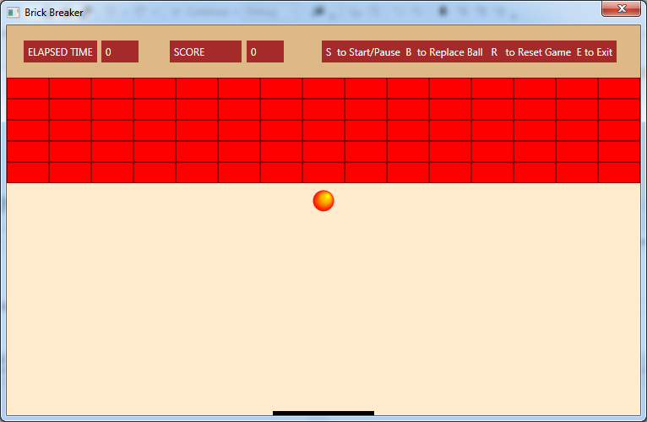

- You must use Observable Collections

- Have fun. Though none of these is required, use different colors. Play around. For instance, try adding a sound when the ball hits and bounces off something (i.e. brick, sides, paddle, bottom). Try adding a bitmap to your bricks to make them look more realistic.

Format: Provide the information as follows:

- Zip project files.
- Upload the zip file via the web to the Blackboard.
- Please include your full name as part of the header in each source file.
- Please append _HW3 to the .zip file name (e.g. waclawski_HW3.zip).

